American Raga Band
Indo-American Raga Jazz Ensemble
Directed by Seema Kasthuri

About the Ensemble
American Raga Band is a pioneering Indo-American fusion ensemble led by vocalist and composer Seema Kasthuri. The ensemble seamlessly bridges Indian classical traditions (Carnatic & Hindustani) with contemporary American jazz, creating immersive musical experiences rooted in raga, rhythm, and improvisation.
Their repertoire includes original compositions, reimagined ragas, devotional works, and collaborative jazz interpretations. Each performance reflects dynamic interplay between voice, Imrat guitar, flute/saxophone, bass, drum set, and Carnatic percussion.

Band Members

Seema Kasthuri – Lead Vocals, Composer
Todd Mosby – Lead Guitarist & Composer (Imrat Guitars)
Prasanna Kasthuri – Mridangam (Indian Classical Percussion)
Steve Davis – Drums
Ben Coan – Bass
Premik Russell Tubbs – Flute, Saxophone (Multi-Instrumentalist)
Additional Artists – Keyboards, Violin, Backup Vocalists

Technical Overview
Downstage Center – Lead Vocal (1 mic + monitor)
Downstage Right – Mridangam (2 microphones – right & left heads + personal monitor)
Additional Mic – 1 Backup Vocal microphone
Stage Left – Keys (DI)
Upstage Left – Bass (Amp + DI)
Upstage Right – Drum Kit (kick, snare, overheads)
Mid-Stage – Guitar & Flute/Sax positions

Stage Plot

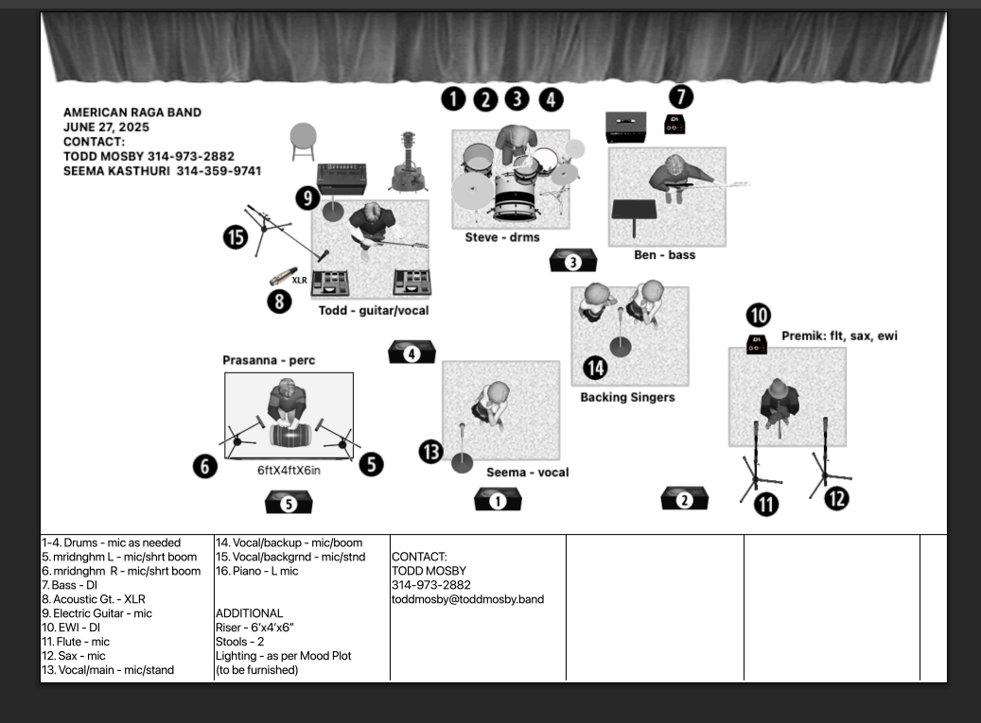

Contact
Seema Kasthuri
Email: seemakasthurimusic@gmail.com
Website: www.seemakasthuri.com
Phone: 313-459-9741
YouTube: https://youtu.be/ASqh6Ed1oxI?si=6FfVHs3TeFLcHAS0

